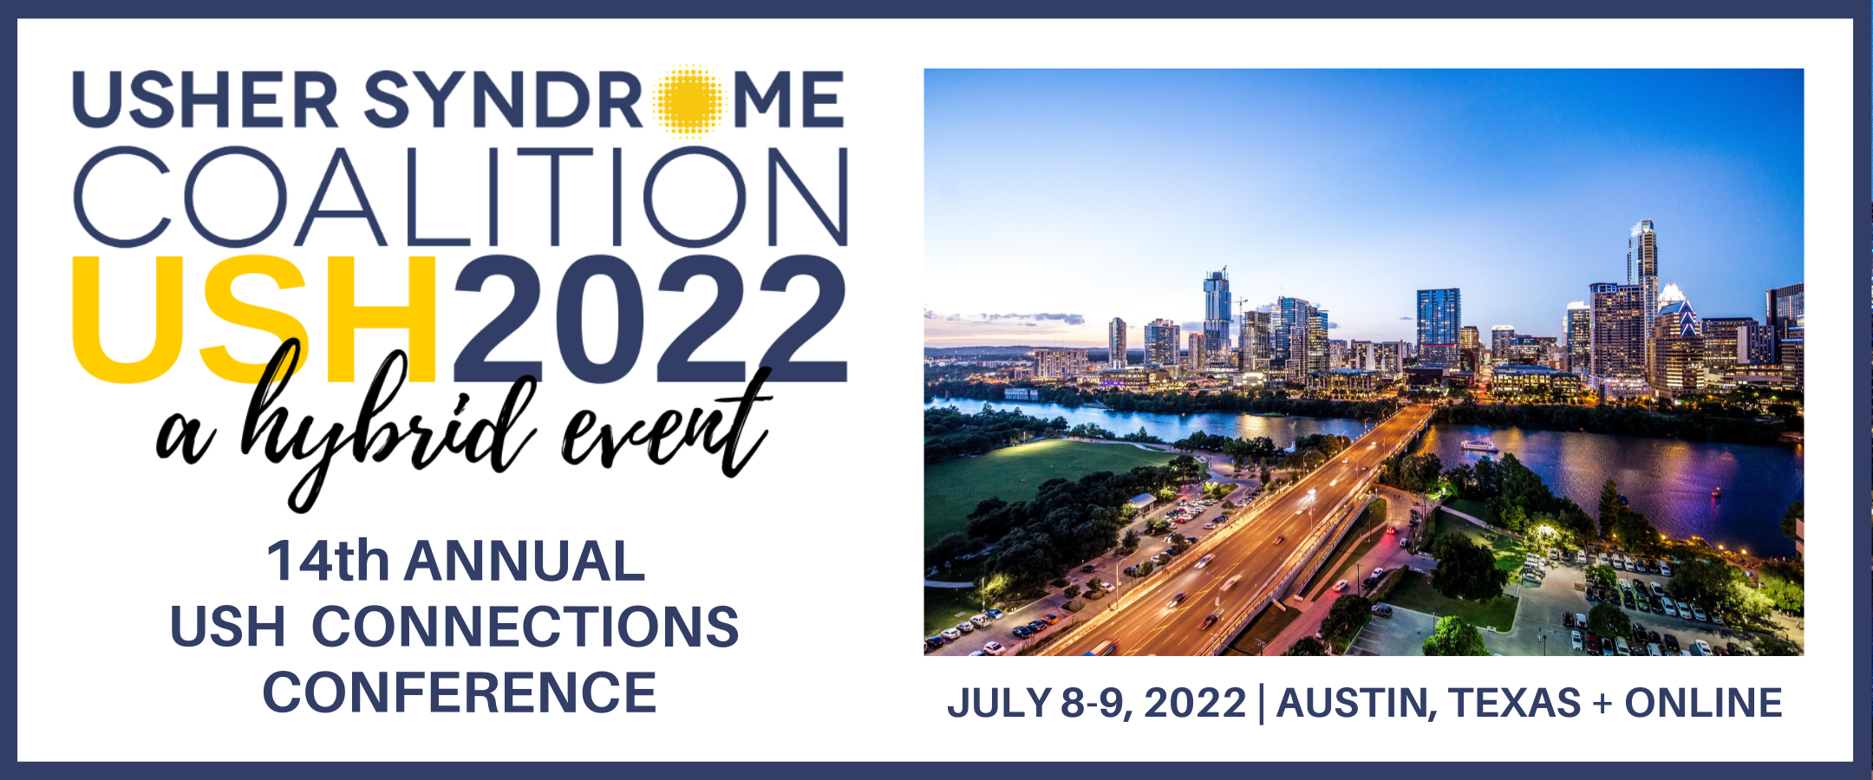

2022 USH Connections Conference
Scholarship Application

The 2022 USH Connections Conference Scholarship Program will enable individuals with Usher syndrome (USH) and their families to attend the 14th Annual USH Connections Conference in-person in Austin, Texas, or virtually, on July 8-9th, 2022. This annual gathering provides the opportunity for individuals with Usher syndrome, family members, friends and professionals to learn of the latest advances in research, while connecting with others impacted by Usher syndrome and engaging with researchers

WHO IS ELIGIBLE?

- Scholarship is based on financial need to enable the inclusion of a family or individual who would otherwise be unable to attend.
- Preference will be given to first time conference attendees.
- Applicant must commit to attending the entire conference and completing the post-conference evaluation.
- Applicant must join the USH Trust Registry. Registration is free and simple. Your privacy is protected and will ensure you will be informed of current clinical trials, studies and the latest advances in research. You can join here: www.usher-registry.org

APPLICATION PROCESS:

- Applicant must submit completed application by April 15, 2022.
- Scholarship award winners will be notified by May 6, 2022.
- Applicant is responsible for their own transportation arrangements.

WHAT DOES THE SCHOLARSHIP COVER?
If recipient chooses to attend in-person:

- Scholarship covers two nights (July 8 and July 9, 2022) at the Austin Southpark Hotel, and conference registration fees (including Friday afternoon breakout sessions, Saturday full-day conference, Saturday breakfast, lunch, evening social and childcare, if applicable) for up to two adults and two children, including the individual with Usher syndrome.
- The individual or family will understand that no cash or check will be furnished to them for the conference. These items will be paid directly by the Usher Syndrome Coalition.

HOW TO APPLY:

- Complete page three of this application form.
- Mail completed form to Krista Vasi, Usher Syndrome Coalition,
9 Cornerstone Square, Suite 400-224, Westford, MA 01886 USA or scan and email form to Krista at k.vasi@usher-syndrome.org.

If you have questions, please email Krista at k.vasi@usher-syndrome.org or call 1-800-946-9203.

2022 USH Connections Conference
Scholarship Application

PERSONAL INFORMATION
Name:
Relationship to individual with Usher syndrome:
Name and age of individual with Usher syndrome:
Have you attended an USH Connections Conference before, and if so, which one(s)?:
Address:
City/State/Zip/Postal Code/Country:
Phone:
Email Address:
Please explain what you hope to gain by attending the conference:

I have read and meet the above listed eligibility terms. If I am unable to attend the conference, I will notify the Usher Syndrome Coalition by May 15, 2022 so that the scholarship may be awarded to another recipient.

Signature Date

