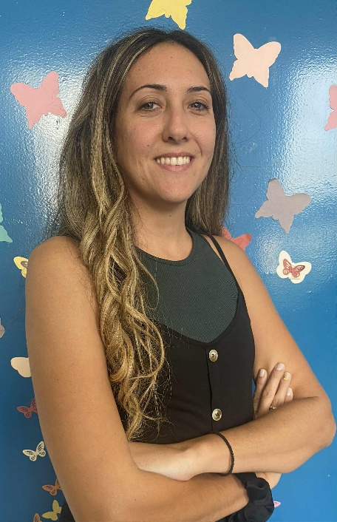
Through darkness, I found my own light
My name is Fotini Tataki. I was born deaf, and later, during elementary school years, I noticed that my peripheral vision wasn’t clear—but at the time I didn’t pay much attention to it. When I joined middle school, my classmates started noticing my vision issues: “Why can’t you see?” or “Are you just being careless?”. Some people misunderstood me, and that convinced me to visit eye specialists. That’s when I was diagnosed with Usher Syndrome.
It was a huge shock for me because I realized I had two conditions, and I struggled to accept it. I’ve always been an athletic person; I loved sports, especially those involving a ball, like volleyball or racket sports. As long as I was still able to see clearly, I kept playing. But I wasn’t courageous enough to tell others about my Usher Syndrome because I felt embarrassed.
Last year, I visited Germany to join a European youth camp for deafblind individuals. That experience was a real “awakening” for me—I understood that I wasn’t alone. There were many people with similar experiences; I met new people and felt truly accepted.
I returned back to Greece full of confidence and I realized that I needed to act and show the world there is no reason to be ashamed of having a second condition. What matters most is accepting who we are and loving ourselves.
Today, I proudly say that I am a deafblind person, and I’m no longer ashamed. On the contrary, I feel strong and grateful for everything I’ve achieved so far. As for sports, I found new ways to express myself, such as through acrobatic dance, which has been incredibly supportive for my emotional well-being.
I no longer try to hide who I am. I am Fotini, and through darkness I found my own light. And that light is something I want to share with others.

