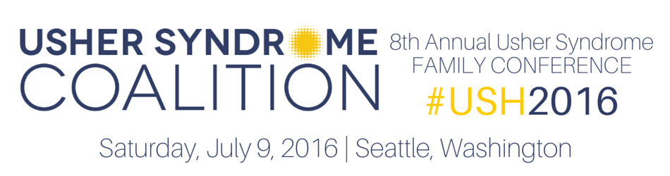
2016 Usher Syndrome Family Conference
Scholarship Application

The 2016 USH Family Conference Scholarship Program, made possible by the Global Genes’ RARE Patient Impact Grant, will enable individuals with Usher syndrome (USH) and their families to attend the 8th Annual Usher Syndrome Family Conference in Seattle, Washington on Saturday, July 9, 2016. This annual gathering provides the opportunity for individuals with Usher syndrome, family members, friends and professionals to learn of the latest advances in research, while connecting with others impacted by Usher syndrome and engaging with researchers who are working tirelessly toward treatments.

WHO IS ELIGIBLE?

- Scholarship is based on financial need to enable the inclusion of a family or individual who would otherwise be unable to attend.
- Preference will be given to first time conference attendees.
- Applicant must commit to attending the entire conference and completing the post-conference evaluation.
- Applicant must join the International Usher Syndrome Registry. Registration is free and simple. Your privacy is protected and will ensure you will be informed of current trails, studies and the latest advances in research. You can join here: www.usher-registry.org

APPLICATION PROCESS:

- Applicant must submit completed application by April 15, 2016.
- Scholarship award winners will be notified after May 1, 2016.
- Applicant is responsible for making their own transportation arrangements.

WHAT DOES THE SCHOLARSHIP COVER?

- Scholarship covers two nights (July 8 and July 9, 2016) at the Washington Athletic Club in Seattle, Washington and covers conference registration fees (including breakfast, lunch, evening social and childcare, if applicable) for up to two adults and two children, in addition to the individual with USH.
- The family will understand that no cash or check will be furnished to them for the conference. These items will be paid directly by the Usher Syndrome Coalition.

HOW TO APPLY:

- Complete page three of this application form.
- Mail completed form to Krista Vasi, Usher Syndrome Coalition, 2 Clock Tower Place, Suite 418, Maynard, MA 01754 USA or scan and email form to Krista at k.vasi@usher-syndrome.org.

If you have questions, please email Krista at k.vasi@usher-syndrome.org or call 1-855-998-7437.


The 2016 Usher Syndrome Family Conference Scholarship Program is made possible by the
Global Genes’ RARE Patient Impact Grant.

2016 Usher Syndrome Family Conference
Scholarship Application

PERSONAL INFORMATION
Name:
Relationship to individual with Usher syndrome:
Name and age of individual with Usher syndrome:
Have you attended an Usher Syndrome Family Conference before, and if so, which one(s)?:
Address:
City/State/Zip/Country:
Phone:
Email Address:
Please describe your need for conference assistance:

Please explain what you hope to gain by attending the conference:

I have read and meet the above listed eligibility terms. If I am unable to attend the conference, I will notify the Usher Syndrome Coalition by May 15, 2016 so that the scholarship may be awarded to another recipient.
Signature Date

